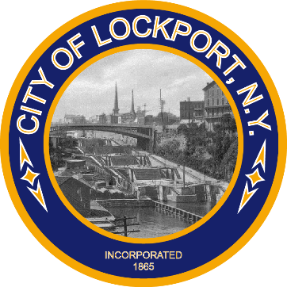LOCKPORT MUNICIPAL BUILDING

One Locks Plaza

Lockport, New York 14094

Phone (716) 439-6665

Fax (716) 439-6668

## JOHN LOMBARDI, III

## MAYOR

*Press Release*

*City of Lockport to Raise Juneteenth and Pride Flags*

*Lockport, NY – June 3rd at Noon and 1 PM*

*Lockport, NY – The City of Lockport is proud to announce a special event featuring the raising of both the Juneteenth and Pride flags on June 3rd on Canal Street. The Juneteenth flag will be raised at 12 noon, followed by the raising of the Pride flag at 1 PM.*

*Juneteenth, celebrated on June 19th, commemorates the emancipation of enslaved African Americans in the United States. It marks the day in 1865 when Union soldiers brought the news of freedom to enslaved people in Galveston, Texas, more than two years after the Emancipation Proclamation was signed. This flag-raising ceremony underscores our commitment to honoring this significant historical event and celebrating the contributions of African Americans to our community and nation.*

*The Pride flag raising at 1 PM signifies our support for the LGBTQ+ community and our dedication to promoting diversity, inclusion, and equality. June is recognized as Pride Month, celebrating the LGBTQ+ community's history, achievements, and ongoing struggle for equal rights.*

*We invite all residents to join us in recognizing these important events and showing support for our diverse community.*

*For more information, please contact: Paula Travis, 716-439-6665.*